**WHO nCOV DATABASE PLATFORM**

**Data extraction Instructions for Open Clinica**

**(version 1.0)**

**Step 1. Go to** [**https://who.eclinicalhosting.com/OpenClinica/pages/login/login**](https://who.eclinicalhosting.com/OpenClinica/pages/login/login)

**Step 2. Log in with Username and Password.**

**Step 3. Welcome Dashboard, change study/site if you are entering data to more than one site.**

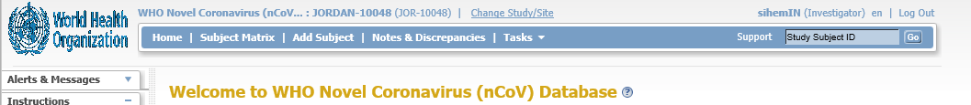

Click here to change study if entering data for more than one site

**Follow these steps:**

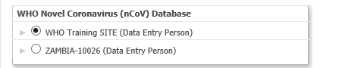

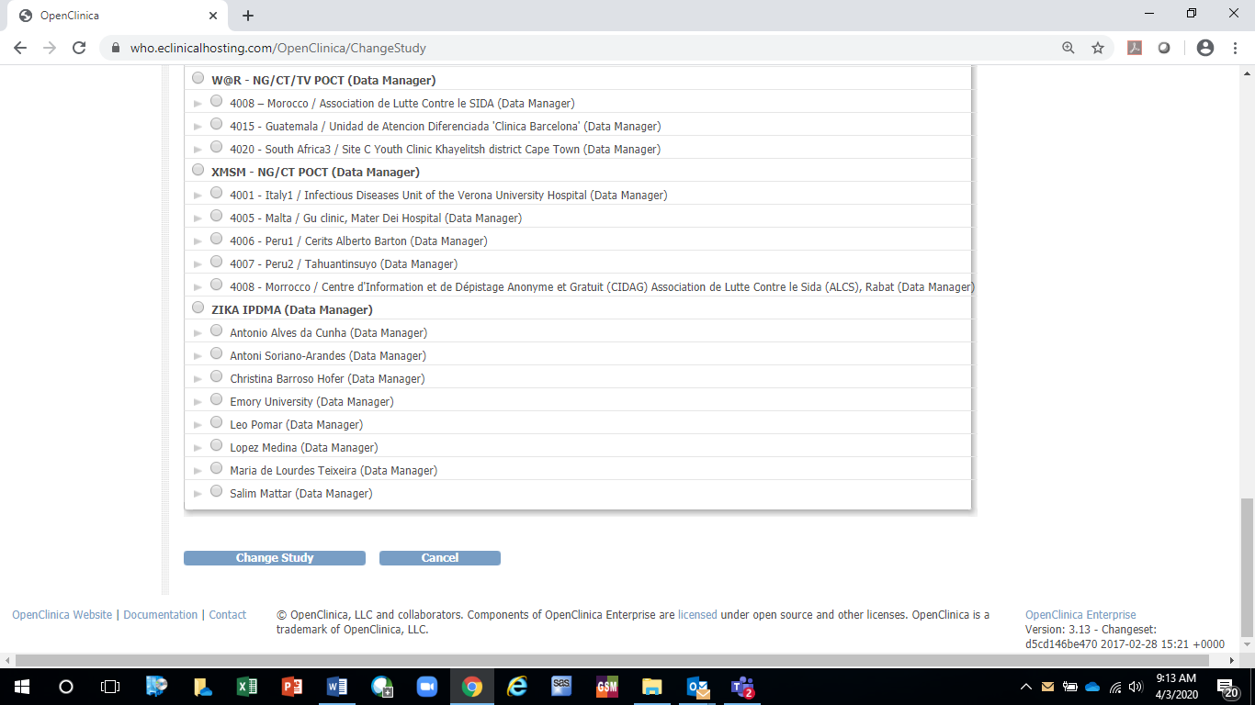

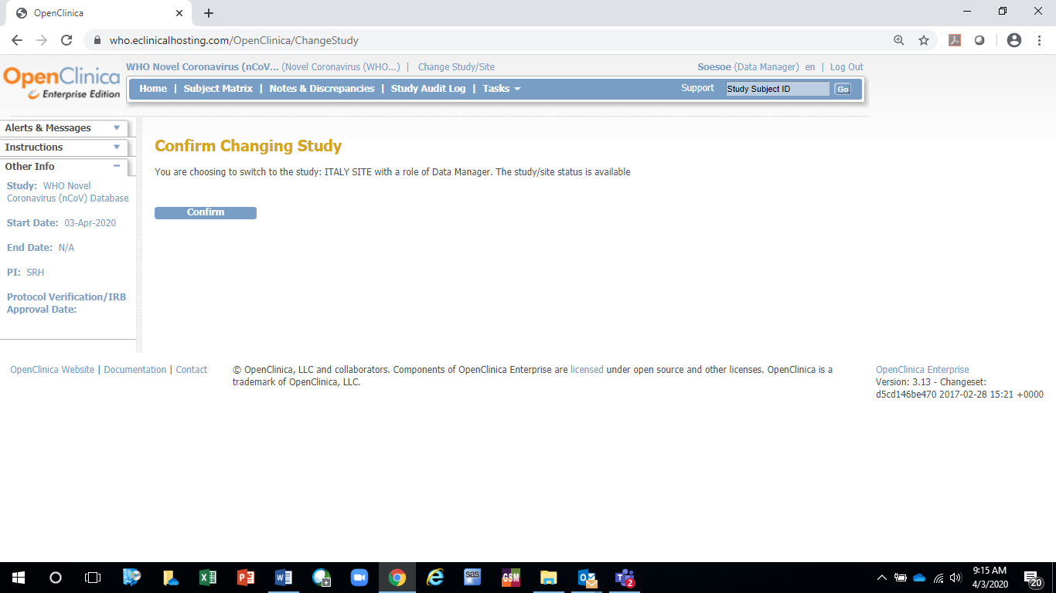

**Step 4. From Welcome Dashboard, click on Tasks/Create Dataset label to create dataset for extraction.**

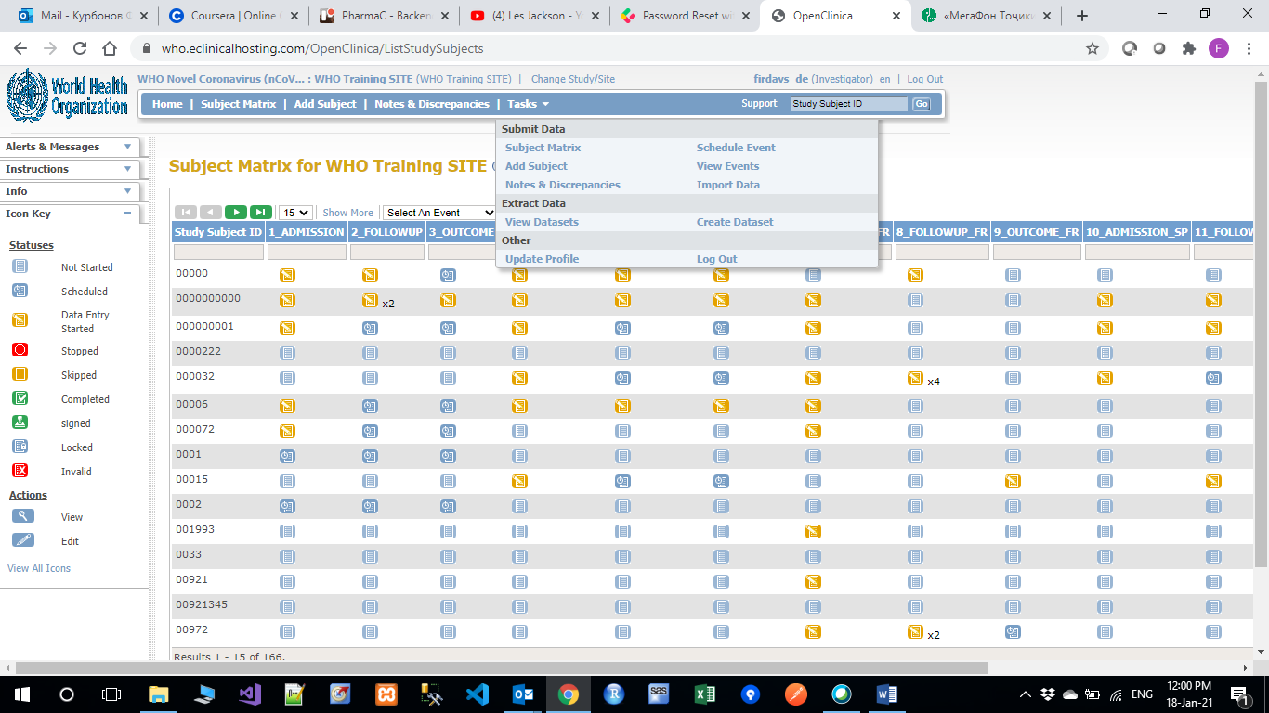

**Step 5. Click on Proceed to Create A Dataset button to start data extraction process.**

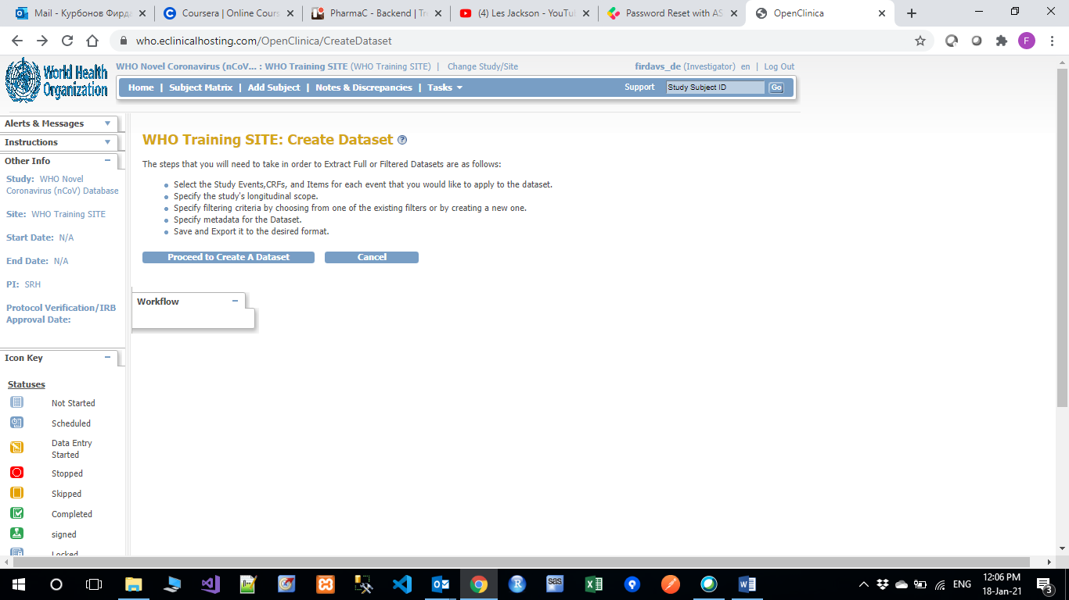

**Step 6. Click on Study Events to select the form which will be extracted.**

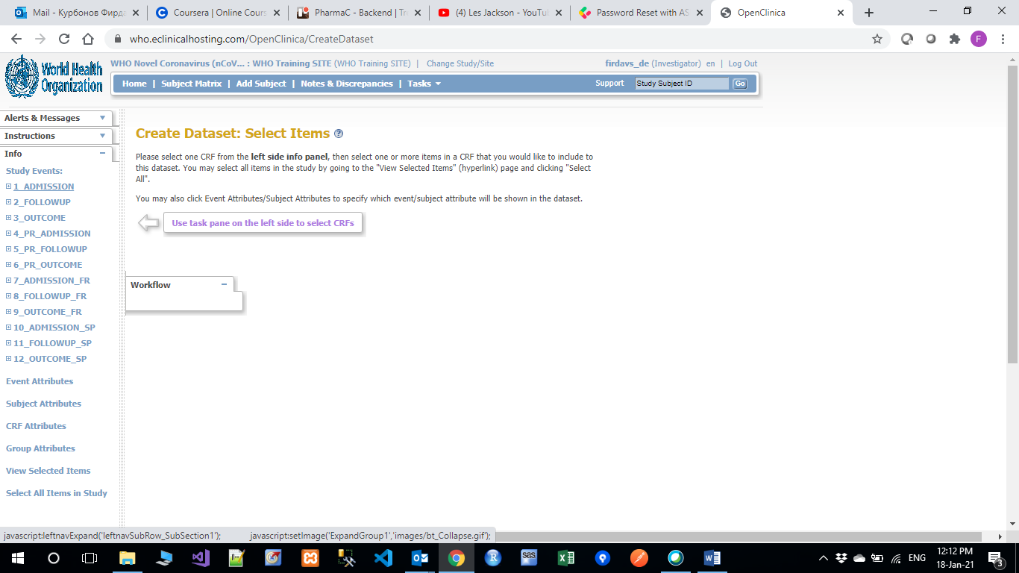

**Step 7. Select the form which will be extracted.**

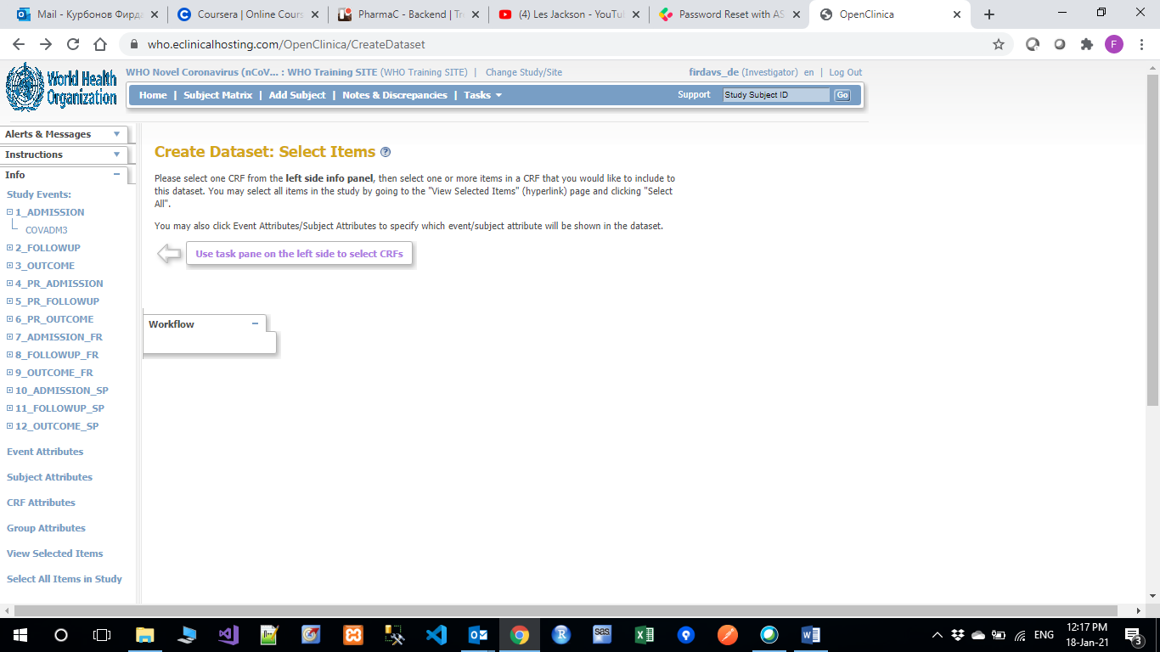

**Step 8. Check Select All Items and click on Save and Add More Items.**

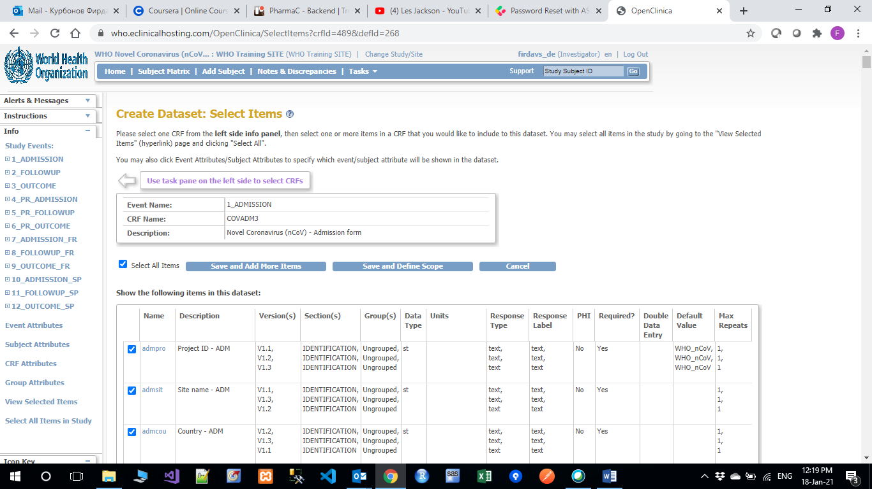

**Step 9. You will see message about selected items and continue selecting other forms for data extraction.**

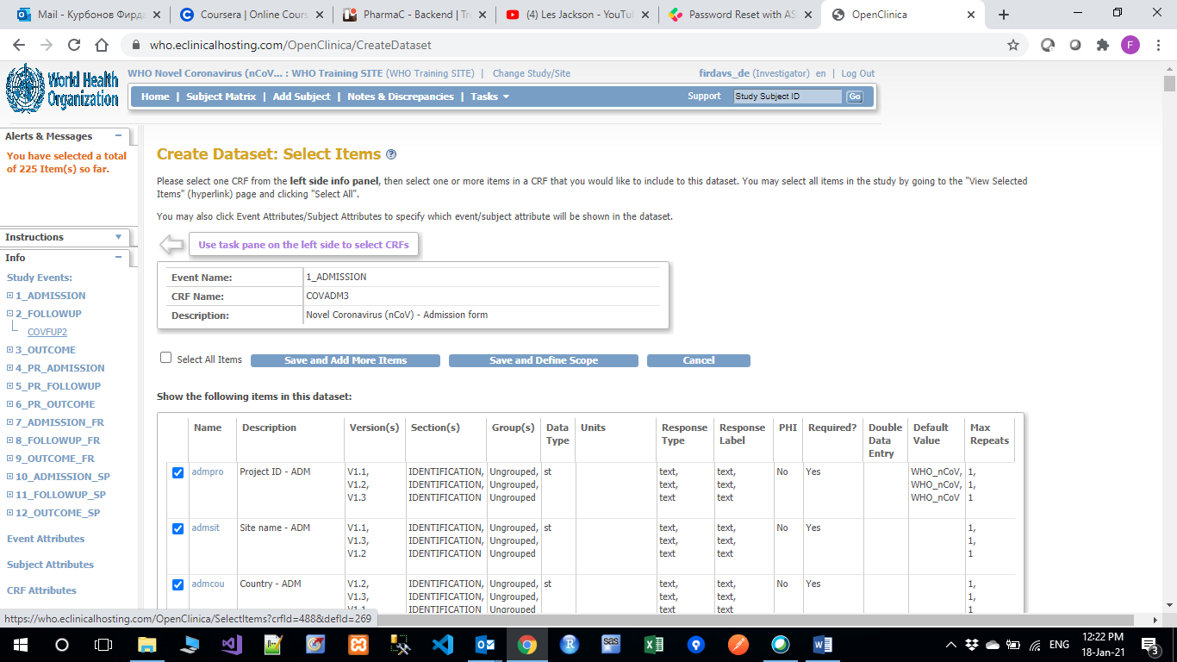

**Step 10. Once selection of forms is finished, click on Save and Define Scope.**



**Step 11. Click on Continue button without Specifying Beginning Date and End Date.**

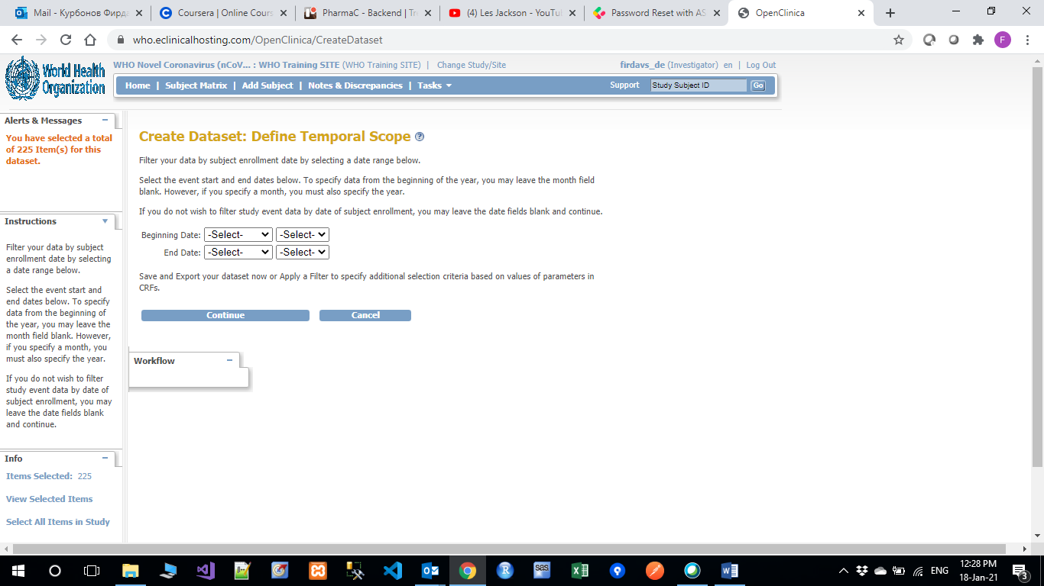

**Step 12. Provide Name and Description, click on Data from all Available CRFs and click on Continue button.**

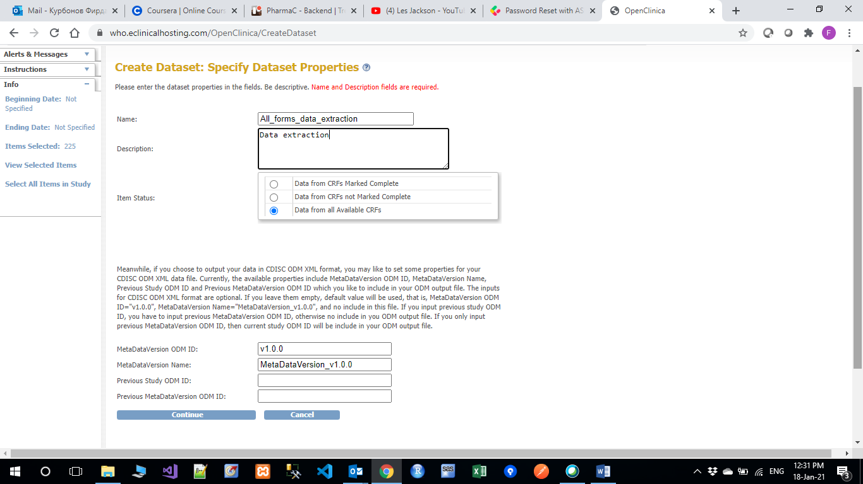

**Step 13. Click on Confirm and Save button.**

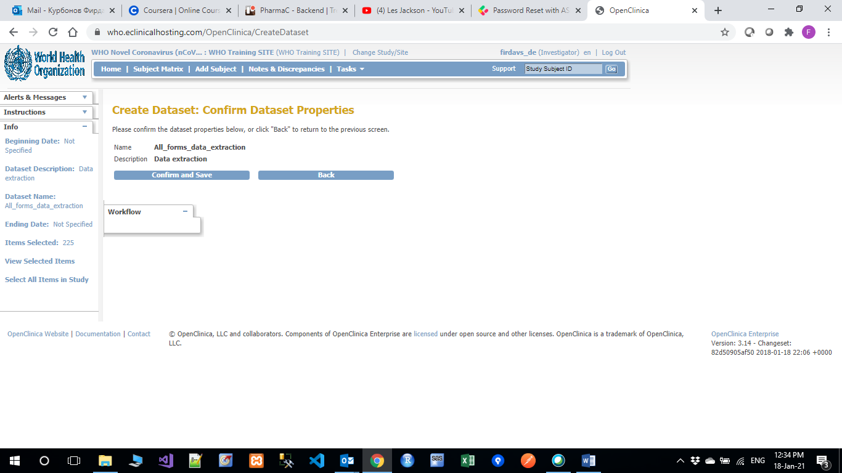

**To continue Data extraction while creating the datasets Follow from Step 16.**

**In case you have already created datasets, you need to click on view datasets for data extraction. No need to create new datasets for each extraction.**

**Step 14. From Welcome Dashboard, click on Tasks/View Datasets option to start data extraction process.**

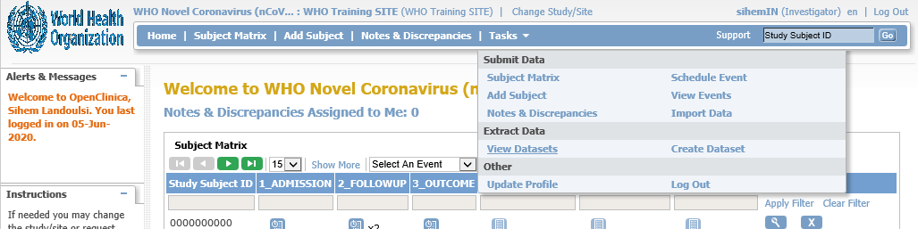

**Step 15. On View Datasets, click on Export Dataset (right arrow) to generate a new dataset.**

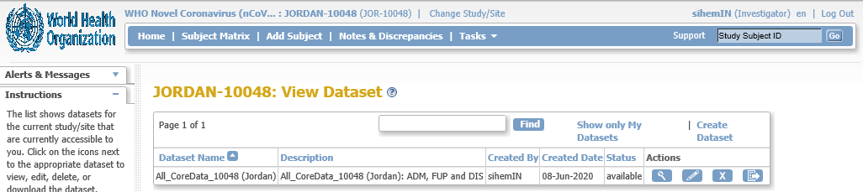

Export Dataset

**Step 16: On Export dataset, click on the format of the dataset that you want to generate: e.g. Excel spreadsheet**

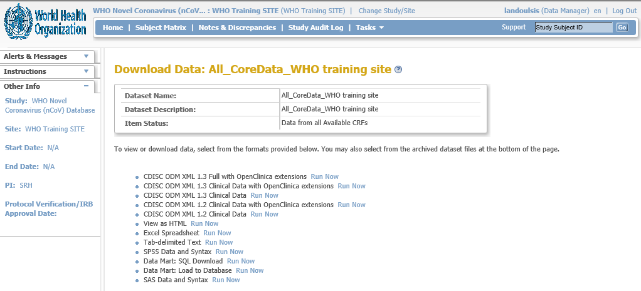

Excel Spreadsheet

Run now

**Step 17: On Export dataset, wait few minutes for data extraction to be done and click on the download arrow to download the dataset**

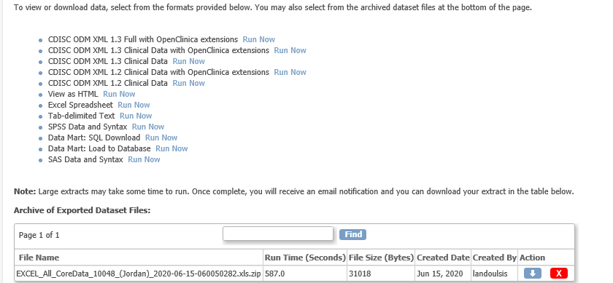

**Step 18: Save you dataset**

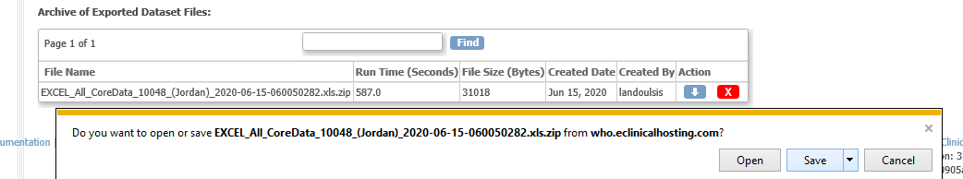

**END.**